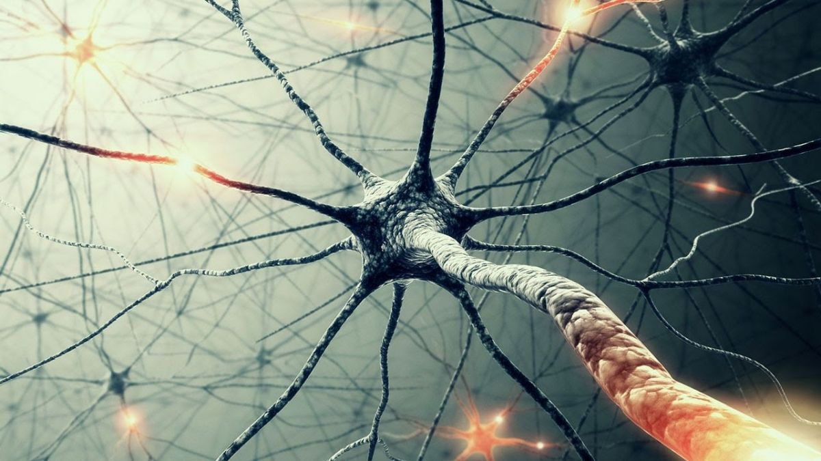

Report - Programming Assignment 1

Team:

Roopali Vij (roopaliv)

Shreeju Jayesh Tanna (shreejuj)

Ranganatha Poola Narayana Swamy (rpoolana)

**Training of Neural Network**

Two of the hyper parameters – Regularization Parameter (lambda) and the number of hidden units were used to train the neural network. Parameter lambda was tried in the range 0 to 60 in increments of 5. Number of hidden units were tried in the range 4 to 48 in increments of 4.

The best results obtained were with the regularization parameter of 5 and the number of hidden units 40 with test set Accuracy of 94.87% and error of 0.39.

The charts below show the variation of accuracy with respect to regularization parameter and the variation of running time of the script with respect to number of hidden units used in the neural network.

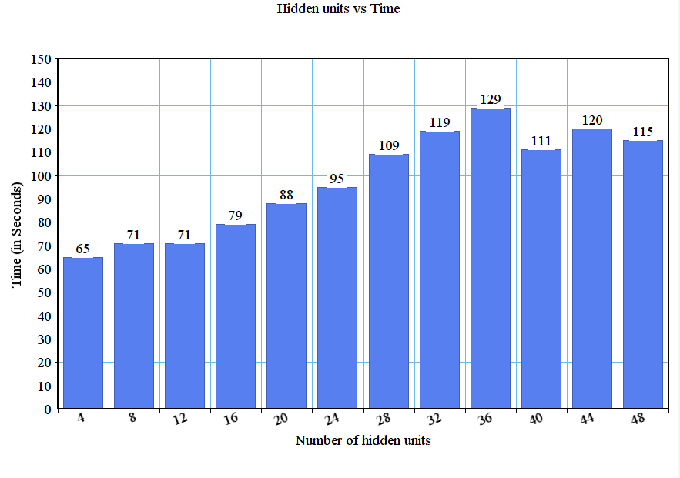

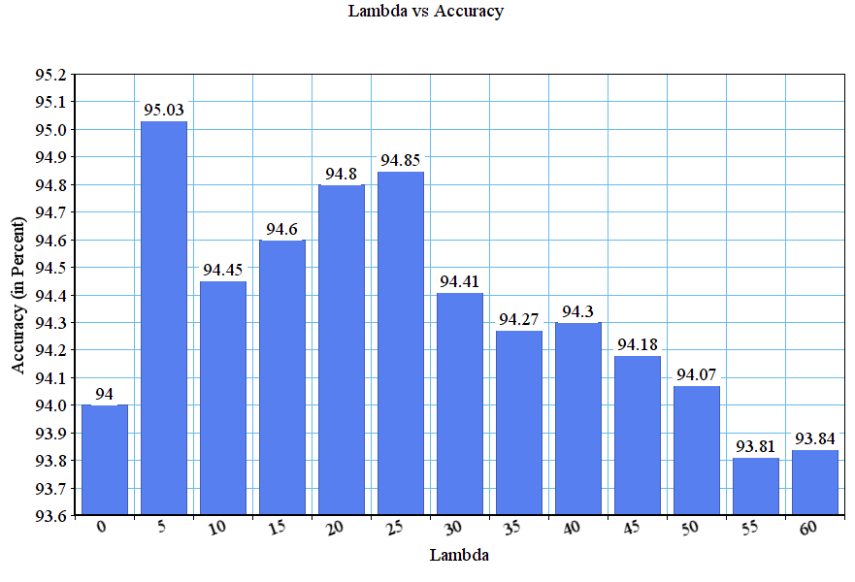

**Accuracy of classification method on the handwritten digits test data**

Hyper parameters:

* Regularization : 5
* Number of hidden units : 40

Results obtained for these parameters are:

* Training set Accuracy : 95.28%
* Validation set Accuracy : 94.61%
* Test set Accuracy : 94.87%

**Accuracy of classification method on the CelebA data set**

Hyper parameters:

* Regularization : 5
* Number of hidden units : 40

Results obtained for these parameters are:

* Training set Accuracy : 84.50 %
* Validation set Accuracy : 83.15 %
* Test set Accuracy: 84.67 %

**Comparison of our neural network with a deep neural network (using TensorFlow) in terms of accuracy and training time**

CelebA dataset was used to compare the performance of our neural network with a deep neural network implemented using TensorFlow library.

Performance of our neural network:

Test set Accuracy : 85.73 %

Time taken in seconds : 290

Performance of deep neural network with a single hidden layer:

Accuracy: 82.74 %

Time taken in seconds : 215

**Performance of Deep Neural Network**

The accuracy of the deep neural network with test data was found to reduce as the number of hidden layers increased. Also, as the number of layers increased, the deep neural network took increasingly more time to execute.

